DTSC 671: AI Solutions in the Cloud

SUBMISSION TEMPLATE:
Text-to-Speech with Amazon Polly

Select File > Make a copy to edit the template and add your screenshots. Download the completed template as a PDF document to submit to Brightspace.

In every screenshot, include your AWS username that appears in the upper right corner. Example:

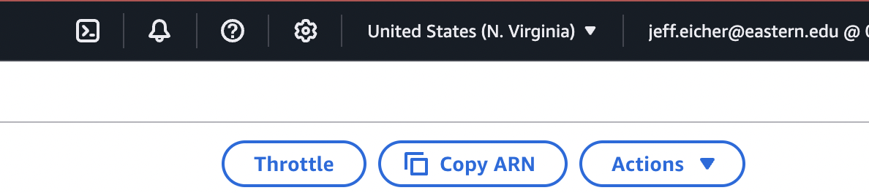

If any one screenshot is missing this identification, the entire assignment will be scored no higher than 70%.

Points totals are provided at the start of each question. You score either full credit or 0 points; there is no partial credit for each question.

- [10 point] In the space below, provide the short text that you chose.

- [10 points] In the space below, provide a screenshot of the Lambda function diagram (with trigger and destination).

- [10 points] In the space below, provide both a screenshot of the beginning of your Lambda code with your account showing, then copy-paste your full lambda code below the screenshot.

- [10 points] In the space below, provide a screenshot of two buckets (one input, one output). You can search by “polly” in S3 to have only the two polly buckets in the list.

- [10 points] In the space below, provide a screenshot of the CloudWatch log streams for your Lambda function. Fit as many as you can in the screenshot.

- [10 points] In the space below, provide a screenshot of the CloudWatch stream that functioned without errors.

- [10 points] In the space below, provide a screenshot of IAM role permissions for the Lambda function.

- [15 points] In the space below, provide a screenshot of the MP3 file in your output bucket.

- [15 points] You will upload your MP3 to Brightspace separately.

